Quantum Computing Task

Our mechanization for Quantum Separation Logic based on the paper presented in POPL’22, together with classical reasoning rules, it introduces separation logic over qubits with the following rules: Qubit, Dispose, qubit state transformation, qubit measurement and a frame rule.
In that paper, the reasoning rule for the Dispose operation cannot be proven sound, due to the decomposition of a tensor product leads to an infinite number of different products, being impossible to obtain the assignment that a particular state might need.
A correct reasoning rule for dispose requires that the qubit to be disposed are fixed, so the tensor product decomposition gives a unique result, enabling soundness of the rule. A solution for this is to reset the qubits that are going to be disposed before invoking the dispose operation.

However, the current framework does not provide a proper reset operational semantics and reasoning rule. It can be extended however following [1]. This paper introduces an initialization operation together with a reasoning rule as it follows:

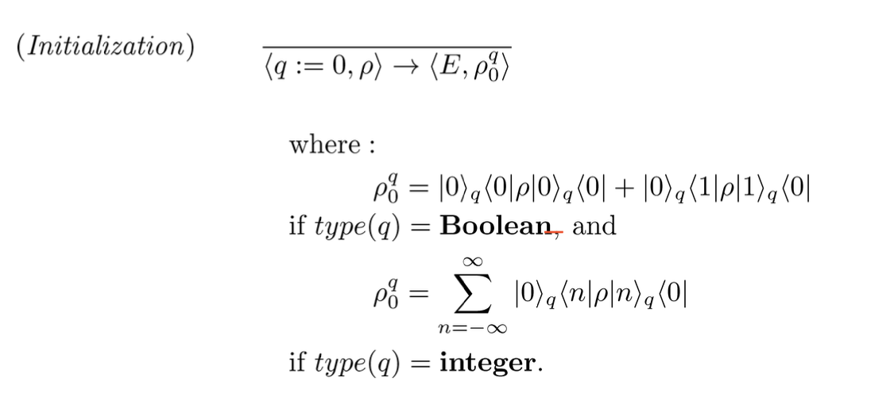
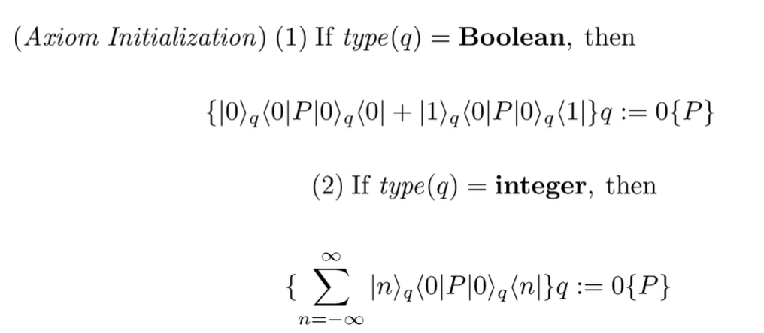
We aim to adapt these rules into our Separation Quantum Computing mechanization, proving that the rule is sound w.r.t to its semantics.
[1] Mingsheng Ying. 2012. Floyd--hoare logic for quantum programs. ACM Trans. Program. Lang. Syst. 33, 6, Article 19 (December 2011), 49 pages. https://doi.org/10.1145/2049706.2049708

